How to Test Transducer Capacitance of 280T

You will need a wire stripper and a multimeter.

1. Cut the transducer cable from integrator end;

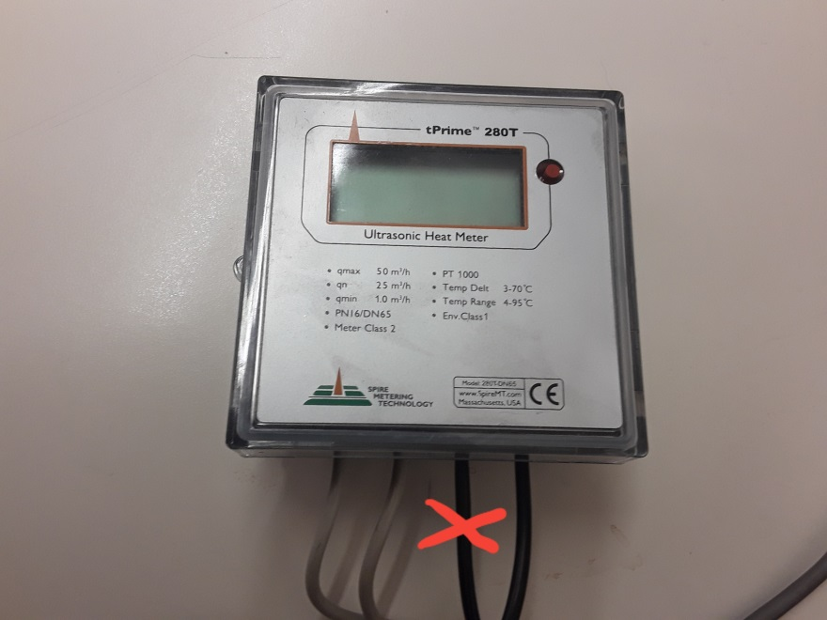

1. Strip the wires, you will have Red, Black and shield as ground;

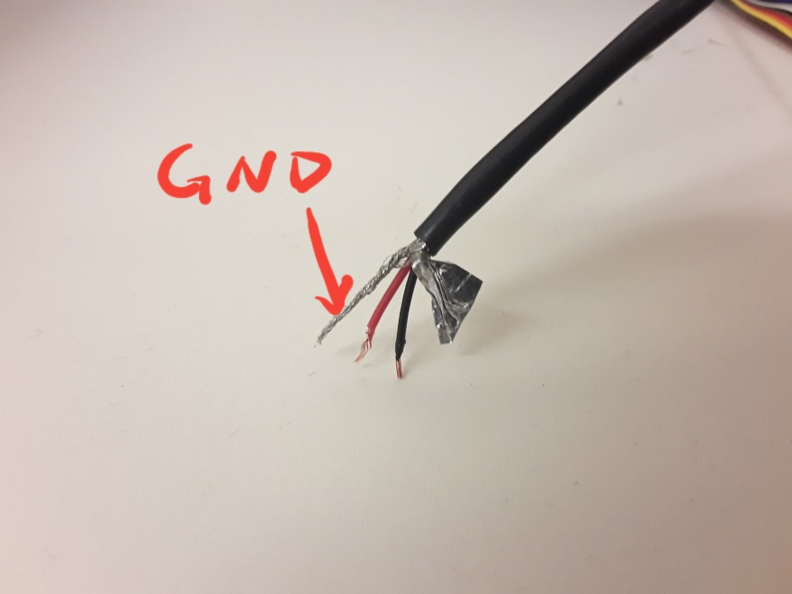

1. Measure capacitance with multimeter between Red and shield ground. You should see the result as 1nF. Please note, do not hold wires with both hand when measuring;

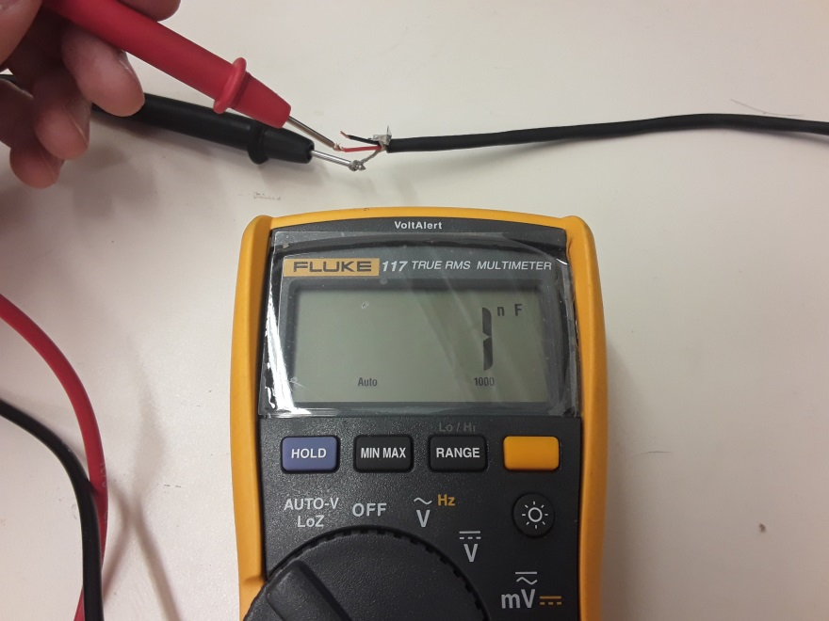

1. Measure capacitance with multimeter between Black and shield ground. You should see the result as 1nF. Please note, do not hold wires with both hand when measuring.

